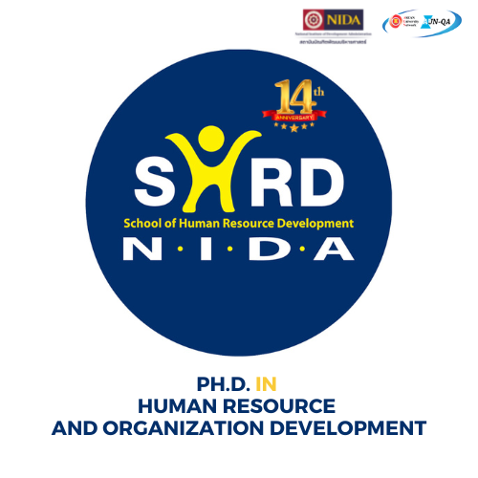
Application Form
Graduate School of Human Resource Development
National Institute of Development Administration

118 Moo3, Sereethai Road, Klong-Chan, Bangkapi, Bangkok 10240 THAILAND

WEB: EMAIL: PHONE: FAX:
www.hrd.nida.ac.th/hrd-phd/ Teerapast.kas@nida.ac.th 66-2375 3876-79 66-2378 001
Please place your
PHOTO here
☺

Application for Admission For Academic Year _____2023______
Please complete every item on this form, sign and date the application, and return it with all required materials.
STUDY PLAN  PLAN A: for Master degree holder  PLAN B: for Bachelor degree holder
Scholarship Request: Are you interested in applying for the scholarship?
 Yes (Please complete scholarship request form on page 4)
 No
Biographical Information
Gender   Male   Female | Last Name First Middle  Your Name in Thai:
Current Mailing Address / Telephone Numbers / E-mail Address

Home : __________________________________________________________________________ Mobile : ___________________________ E-mail : ________________________________
Permanent Mailing Address and Telephone Number

Home : __________________________________________________________________________

Telephone : ___________________________
Date of Birth : dd/mm/yyyy |  | Thai Identification Number / Passport Number :
If you are NOT a THAI citizen, please advise your current immigration status in Thailand.

 THAILAND Alien Registration Number _________________________________________

 Non-Immigrant Visa type _____________________________
Important NOTE: In order to register as a student, NIDA requires that applicants who are not THAI Citizens or THAI Permanent Residents obtain and maintain an appropriate visa status for their stay in THAILAND.

Major Honor /Award/ Academic and/or Professional extensive prowess, if any
English Proficiency Test Score |  | Score |  |  |  | Test Date
 TOEFL
 IELTS (Academic)
 TOEFL / ITP
NOTE: Official TOEFL (min. 550 paper-based, 80 for internet-based test, 231 for computer-based test) or IELTS (min. 6.5, academic format) test scores. TOEFL test score of 500 or equivalence can be submitted under the condition to take at least 2 English classes required at School of Language and Communication, NIDA
*** Except for applicant who either come from English speaking nations or graduated from undergraduate program which used English as the medium of instruction no longer than five years.
WORK EXPERIENCE : List all previous and present works
Name of Company/Organization |  |  | Position Title |  |  |  | Year
Have you ever attend/enroll in any course at NIDA?  Yes  No
If yes, give the school name and year of study _________________________________________

Academic Background
List every college and university you have attended full-time for one academic year or more, and any degree program in which you are currently enrolled. List schools chronologically, starting with your undergraduate degree first.
Collage / University | From: To:  (Month & Year) |  |  | Majors | GPA |  |  | Degree or Diploma earned / expected
1. Have you ever been suspended or dismissed from any school or college? Yes  No

2. Have you ever been convicted of a felony?  Yes  No

If you answered yes to either of these questions, please explain on a separate sheet or paper.

If you have not graduated yet, what is the proposed date of your graduation (mm/yyyy)?

Please tell us how you learned about our program:

Please list honors, fellowships, academic/professional you have received, if any, that reflect(s) most clearly your success potential in doctoral study in our program.

Contact person at the certified organization/agency we could contact to verify your honor/award mentioned above. Attach additional sheets as needed.
Name ___________________________________ Position _______________________________________
Telephone __________________________________Email ________________________________________
or Affiliation / Organization _________________________________________________________________

Who will support your study financially?
 Self Support  Organization  University  Other sources ………………………
 | I hereby certify that all information given in this application is correct, and true to the best of my knowledge at the date signed. I understand that giving false information or withholding information may result in my ineligibility for admission or to continue my enrollment at the NIDA
 | Signature |  | Date
 | Do Not Write Below This Line : For Office Use Only
NOTE:
All admission materials submitted become the property of the National Institute of Development Administration and cannot be forwarded or returned. They will be kept confidentially and be active for a 12-month period only.
 | Admission Action :  Approve   Not Approve |  |  | Date :
 | Remark : |  |  | By :
Scholarship Request:
Are you interested in applying for the scholarship?  Yes  No
Which Type of the scholarship are you interested in?  Type 1  Type 2  Type 3
Types of Scholarship: |  | Condition:
Type 1  - 3 year scholarship (under condition)  - Tuition and fees exemption  (THB 8,500 per credit)  - Monthly stipend from the institution |  | - Bachelor’s degree GPA of 3.00 or above  - Master’s degree GPA of 3.50 or above  - Students must maintain GPA at the minimum of 3.30 If students fail to perform accordingly, the scholarship will be terminated  - The student must maintain GPA at the minimum of 3.50 If students fail to perform accordingly, the month stipend from the institution will be terminated.  - Scholarship recipients must complete the degree in accordance with the program's requirement without any kind of academic suspension or leave from the program. Failure to do so, the total of the scholarship must be reimbursed to the program as students’ responsibility.  - Withdrawing from or failing to complete a course with a grade of "C" or better will result in termination of scholarship.  - Scholarship recipients are responsible to pay students activities fee of THB 30,000 per semester (Total of THB 120,000)  *The program requires scholarship recipients to study in the program on a full-time basis*  (Full-time students are not allowed to be employed full-time)
Type 2  - 3 year scholarship (under condition)  - Tuition and fees exemption  (THB 8,500 per credit)  - This scholarship type does not cover the administration fee, library fee, IT fee, and qualifying examination fee |  | - Bachelor’s degree GPA of 2.75 or above  - Master’s degree GPA of 3.50 or above  - Students must maintain GPA at the minimum of 3.30. If students fail to perform accordingly, the scholarship will be terminated  - Scholarship recipients must complete the degree in accordance with the program's requirement without any kind of academic suspension or leave from the program. Failure to do so, the total of the scholarship must be reimbursed to the program as students’ responsibility.  - Withdrawing from or failing to complete a course with a grade of "C" or better will result in termination of scholarship.  - Scholarship recipients are responsible to pay students activities fee of THB 30,000 per semester (Total of THB 120,000)
Type 3  - 3 year scholarship (under condition)  - Partial tuition and fees exemption  (THB 4,250 per credit)  - This scholarship type does not cover the administration fee, library fee, IT fee, and qualifying examination fee |  | - Bachelor’s degree GPA of 2.75 or above  - Master’s degree GPA of 3.50 or above  - Students must maintain GPA at the minimum of 3.30. If students fail to perform accordingly, the scholarship will be terminated  - Scholarship recipients must complete the degree in accordance with the program's requirement without any kind of academic suspension or leave from the program. Failure to do so, the total of the scholarship must be reimbursed to the program as students’ responsibility.  - Withdrawing from or failing to complete a course with a grade of "C" or better will result in termination of scholarship.  - Scholarship recipients are responsible to pay students activities fee of THB 30,000 per semester (Total of THB 120,000)

